**04-06-2025**

**Virtual Machines (VMs)**

**What is a Virtual Machine?**

A **Virtual Machine (VM)** is a software-based computer that runs inside your actual (physical) computer. It acts like a real computer with its own operating system, storage, CPU, and memory, but it's **completely virtual**—meaning it's simulated using software.

Think of a VM as a **computer within your computer**.

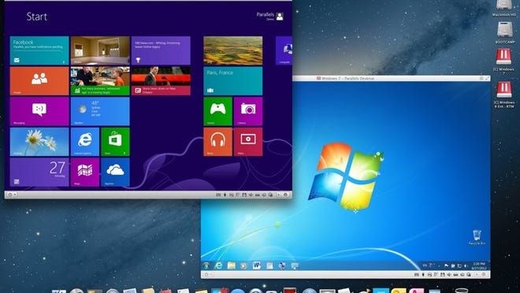

**Simple Analogy**

Imagine your physical computer is a **house**, and inside it, you build a **small apartment** where someone else can live independently. This apartment has its own kitchen, bathroom, and bedroom. Similarly, a virtual machine runs its **own operating system and apps**, while sharing the real computer’s hardware (like CPU, RAM, and storage).

**How Does a Virtual Machine Work?**

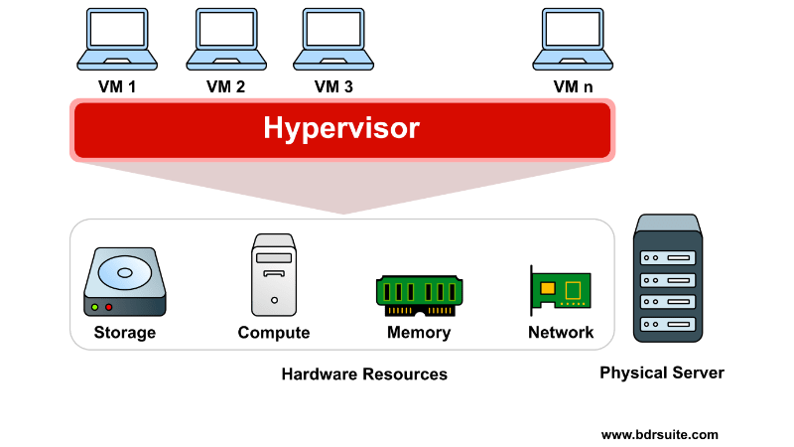

To create and run a virtual machine, you need software called a **hypervisor** (like VirtualBox, VMware, or Hyper-V). This hypervisor creates and manages virtual machines.

Each VM has:

* Its **own operating system** (called the **guest OS**)
* Its **own virtual hardware** (like virtual CPU, memory, and hard disk)

The **host OS** is the actual system installed on your computer (like Windows 11), and the VMs run inside it.

**Real-Life Use Case**

Let’s say you're using Windows 11, but you want to learn Linux. Instead of removing Windows or doing a dual-boot, you can:

1. Download VirtualBox.
2. Create a virtual machine.
3. Install Ubuntu Linux inside it.

Now, you can use both Windows and Linux at the same time, switching between them easily.

**Why Use a Virtual Machine?**

| **🔹 Purpose** | **🔹 Explanation** |
| --- | --- |
| Testing OS & Apps | Try out Linux, Windows Server, or macOS safely |
| Safe Experimentation | Try unknown software without affecting your real PC |
| Developer Testing | Developers test apps on different platforms |
| Enterprise Use | Companies run many servers on one powerful machine |
| Learning & Practice | Learn ethical hacking, databases, or programming |

**Benefits of Using a VM**

* **Isolation**: Problems in one VM don’t affect the main OS.
* **Flexibility**: You can run multiple OSs (Windows, Linux, etc.) on one machine.
* **Cost-saving**: No need to buy more hardware.
* **Revert Back Easily**: Take “snapshots” and roll back if something goes wrong.
* **Cross-platform use**: Run apps made for other operating systems.

**Requirements for Smooth VM Use**

To use virtual machines effectively, your physical computer needs:

* At least **8 GB RAM**
* A **multi-core CPU**
* **50 GB or more** free disk space
* Virtualization enabled in BIOS/UEFI

**Limitations**

* VMs use a lot of system resources (RAM and CPU).
* Performance may not be as fast as a real physical system.
* Some games and heavy apps (like AutoCAD, Photoshop) may not work smoothly.
* Limited by the host machine's hardware.

**Conclusion**

Virtual machines are a powerful tool that lets you do more with your existing computer. Whether you're a student, developer, or IT professional, VMs offer a safe, flexible, and cost-effective way to explore multiple operating systems and run various applications without needing multiple devices.